Pedantic Diction

🧐 What is Pedantic Diction
# Source: AI Source: Provided by: [Data Path: Persons Table -> ID Column: 1, Name_En Column: Motasem Essam] -> From: [Chatgpt (GPT-4-turbo)] on [7/30/2025]
Pedantic diction refers to language that is overly concerned with formal rules, accuracy, and minute details. It often sounds pretentious, academic, or overly precise, especially when used unnecessarily in casual contexts.

✅ Key Features:
# Source: AI Source: Provided by: [Data Path: Persons Table -> ID Column: 1, Name_En Column: Motasem Essam] -> From: [Chatgpt (GPT-4-turbo)] on [7/30/2025]
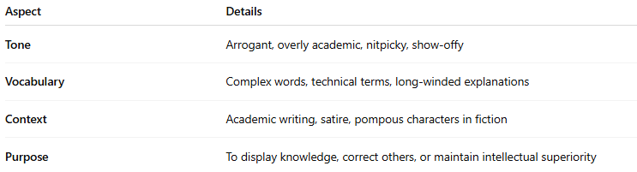
Aspect | Details
Tone | Arrogant, overly academic, nitpicky, show-offy
Vocabulary | Complex words, technical terms, long-winded explanations
Context | Academic writing, satire, pompous characters in fiction
Purpose | To display knowledge, correct others, or maintain intellectual superiority

🧠 Examples of Pedantic Diction:
# Source: AI Source: Provided by: [Data Path: Persons Table -> ID Column: 1, Name_En Column: Motasem Essam] -> From: [Chatgpt (GPT-4-turbo)] on [7/30/2025]
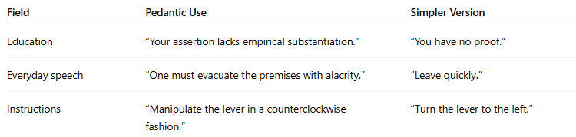
Field | Pedantic Use | Simpler Version
Education | “Your assertion lacks empirical substantiation.” | “You have no proof.”
Everyday speech | “One must evacuate the premises with alacrity.” | “Leave quickly.”
Instructions | “Manipulate the lever in a counterclockwise fashion.” | “Turn the lever to the left.”

✍️ Example Sentences Using Pedantic Diction:
# Source: AI Source: Provided by: [Data Path: Persons Table -> ID Column: 1, Name_En Column: Motasem Essam] -> From: [Chatgpt (GPT-4-turbo)] on [7/30/2025]
- “I couldn’t help but notice that your application of the subjunctive mood is, regrettably, erroneous.”
- “According to Section 4.3 of the procedural framework, your behavior is noncompliant.”

🆚 Pedantic Diction vs Didactic Diction:
# Source: AI Source: Provided by: [Data Path: Persons Table -> ID Column: 1, Name_En Column: Motasem Essam] -> From: [Chatgpt (GPT-4-turbo)] on [7/30/2025]
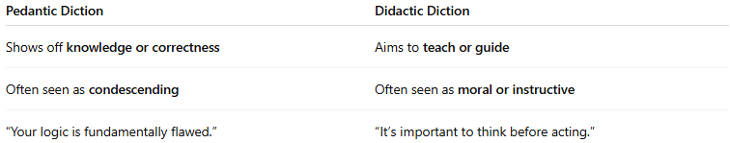
Pedantic Diction | Didactic Diction
Shows off knowledge or correctness | Aims to teach or guide
Often seen as condescending | Often seen as moral or instructive
“Your logic is fundamentally flawed.” | “It’s important to think before acting.”

🧭 Used In:
# Source: AI Source: Provided by: [Data Path: Persons Table -> ID Column: 1, Name_En Column: Motasem Essam] -> From: [Chatgpt (GPT-4-turbo)] on [7/30/2025]
- Academic writing (overly formal)
- Satirical or humorous works
- Characters in literature who act superior
- Excessively detailed manuals or emails

